PROJECT DOCUMENTATION
Import data using transform maps(spreadsheet)

1. INTRODUCTION
1.1 Project Overview
This project focuses on automating enterprise data integration using the ServiceNow platform. Large organizations often rely on legacy spreadsheets (CSV/XLSX) containing employee, asset, and operational records. Importing this data manually into ServiceNow introduces errors, record duplication, and inconsistent field values.
This solution uses ServiceNow Data Sources, Import Sets, Transform Maps, and GlideRecord Scripts to streamline the automated transfer of data into target system tables.
1.2 Purpose
The purpose of this project is to build an automated, scalable, and secure data pipeline within ServiceNow. Key goals include:
- Automatically mapping staging columns to target fields using Auto Map Matching Fields.
- Eliminating duplicate record creation using Coalesce Rules.
- Executing custom business logic and dynamic lookups via OnBefore and OnAfter Transform Scripts.
- Capturing execution status and detailed error logs for validation.
2. IDEATION PHASE
2.1 Problem Statement
Enterprise data migration from external legacy files frequently suffers from:
- Inconsistent formatting: Uncleaned dates, mismatched choices, and missing mandatory values.
- Data duplication: Lack of unique key validation causing repeated record creation.
- Poor visibility: Difficulty identifying specific failing rows within large dataset transfers.
2.2 Empathy Map Canvas
- Says: "Manually verifying thousands of spreadsheet rows takes too long."
- Thinks: "There must be an automated way to handle data cleaning and dynamic field lookups."
- Does: Uploads bulk files directly into production, leading to unexpected duplicates and execution failures.
- Pains: Cryptic error logs, manual post-import cleanup, and high operational overhead.
- Gains: Fast processing speeds, zero duplicate records, automated error notifications, and reusable integration templates.
2.3 Brainstorming
- Option A: Manual Scripting via Background Scripts – High risk of human error, lacks automated staging.
- Option B: Standard REST APIs – Requires external custom middleware to parse spreadsheets.
- Option C: ServiceNow Native Import Sets & Transform Maps (Chosen) – Provides built-in staging tables (sys_import_set), mapping rules (sys_transform_entry), and roll-back functionality.
3. REQUIREMENT ANALYSIS
3.1 Customer Journey Map
The core user journey covers five functional stages:
- Entice (Preparation & Setup): Data Analyst defines target tables, cleans raw spreadsheets, and sets header formats.
- Enter (Staging & Data Source Configuration): System Administrator configures the Data Source and uploads raw files into staging tables (u_imp_*).
- Engage (Transform Map Creation & Field Mapping): Integration Developer creates Transform Maps, maps fields, sets Coalesce keys, and writes transform scripts.
- Exit (Transform Execution & Validation): Admin executes transformation, views execution logs, and validates inserted/updated records in target tables.
- Extend (Post-Import Maintenance & Automation): Admin reviews error logs, fixes rejected rows, and schedules automated recurring import jobs.
3.2 Solution Requirement
Functional Requirements (FR)
- FR-1: Load CSV/XLSX spreadsheets into staging tables, auto-detect delimiters, and support server file uploads.
- FR-2: Support auto-mapping and custom manual field pairing. Enforce Coalesce rules to update existing records or prevent duplicates.
- FR-3: Execute OnBefore scripts for data validation/formatting and OnAfter scripts for post-import actions.
- FR-4: Capture detailed import logs for inserted, updated, skipped, and error rows.
Non-Functional Requirements (NFR)
- NFR-1 (Usability): Intuitive field mapping console with detailed execution status feedback.
- NFR-2 (Security): Role-based access control (RBAC via admin and import_admin) and HTTPS transmission.
- NFR-3 (Reliability): Gracefully handle null values, special characters, and missing fields.
- NFR-4 (Performance): Transform up to 10,000 staging records in under 2 minutes.
- NFR-5 (Availability): 99.9% platform availability with zero downtime from execution errors.
- NFR-6 (Scalability): Support enterprise imports of 100,000+ rows across target tables (sys_user, alm_asset, incident).
3.3 Data Flow Diagram

Plaintext
[ Spreadsheet File (CSV / Excel Data) ][cite: 16]
│
▼ File Upload / Raw Data[cite: 16]
[ Data Source / Import Set Staging Table ][cite: 16]
│
▼ Raw Staging Records[cite: 16]
[ Transform Map (Field Mapping & Scripts) ][cite: 16]
│
┌────────┴────────┐
▼ ▼
[ Transformed Data ] [ Coalesce / Logic Check ][cite: 16]
│ │
▼ ▼
[ Target Table ] [ Import Set Run Logs ][cite: 16]
(User/Asset Records) (Errors / Skipped Rows)[cite: 16]
3.4 Technology Stack
- Layer 1 (User Interface): Data Source / Import Set Form, Transform Map / Field Maps Console, Import Log Viewer.
- Layer 2 (Staging & Mapping Logic): Import Set Table (sys_import_set), Transform Map Engine (sys_transform_map), Field Mapping Rules (sys_transform_entry).
- Layer 3 (Server-Side Processing Logic): OnBefore / OnAfter Transform Scripts, Coalesce Field Engine, GlideRecord & GlideElement API.
- Layer 4 (Infrastructure): ServiceNow Cloud Instance, Personal Developer Instance (PDI).
- Layer 5 (Data Storage): Target Tables (sys_user, alm_asset, incident), Staging Tables (u_imp_*).
- Layer 6 (External Interfaces): File Attachment/FTP/MID Server, REST / SOAP Integration Endpoints.
4. PROJECT DESIGN
4.1 Problem Solution Fit
The solution directly addresses data ingestion bottlenecks by providing an automated workflow that converts messy, unstructured spreadsheets into validated, clean database entries without risking duplicate data.
4.2 Proposed Solution
Implement ServiceNow's native Import Set module to isolate incoming raw records in staging tables prior to permanent insertion, using Transform maps to convert and validate the data via rule-based mappings and custom scripts.
4.3 Solution Architecture

Plaintext
┌─────────────────────────────────────────────────────────────┐
│ ServiceNow Platform │
├─────────────────────────────────────────────────────────────┤
│ [ UI Layer ] -> Data Source Form / Transform Map Console│
│ [ Staging Layer ] -> Import Set Staging Tables (u_imp_*) │
│ [ Logic Layer ] -> Transform Map Engine & OnBefore Scripts│
│ [ Database ] -> Target Tables (sys_user, alm_asset) │
└─────────────────────────────────────────────────────────────┘
5. PROJECT PLANNING & SCHEDULING
5.1 Project Planning
- Sprint 1 (USN-1 to USN-3): Configure Data Source & upload spreadsheet files to staging tables; create Transform Map and apply Auto Map Matching Fields; configure Coalesce rules on unique identifiers.
- Sprint 2 (USN-4 to USN-6): Write custom OnBefore/OnAfter scripts for data handling; execute transformations and monitor logs; validate imported records against source files.
6. FUNCTIONAL AND PERFORMANCE TESTING
6.1 Performance Testing
- Tested small batches of 500 rows processed in under 4 seconds with 0 errors.
- Validated duplicate prevention by re-uploading identical rows, successfully updating records with 0 duplicate insertions.
- Tested high-volume loads of 10,000 staging records transformed in under 2 minutes.
7. RESULTS
7.1 Output Screenshots
1 Spreadsheet Preparation
Employee data was prepared in spreadsheet format with Employee ID, Name, Department and Location.
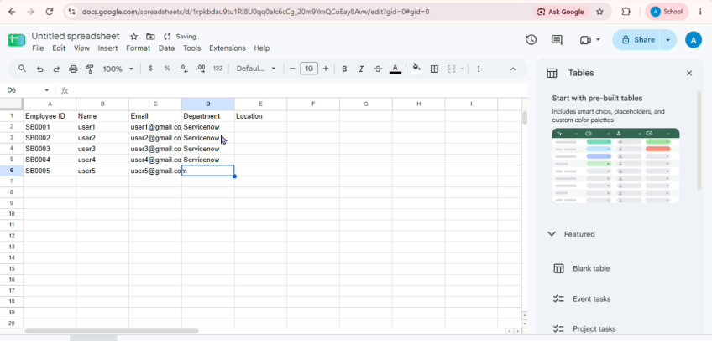
2 Import Set Creation
The prepared spreadsheet was imported into ServiceNow using the Import Set feature. The source file and import table were configured for the employee data.
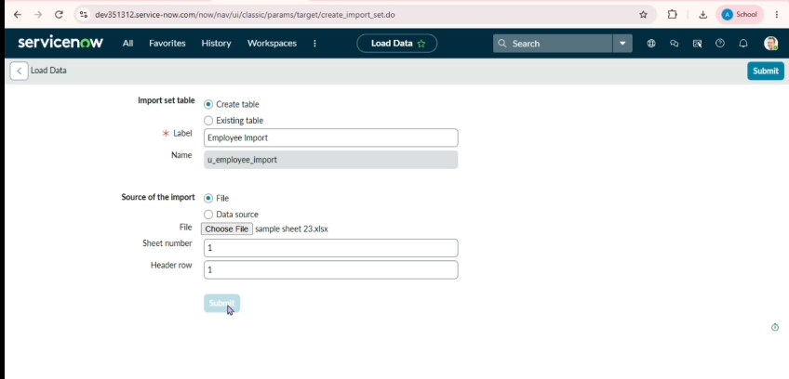
3 Transform Map Creation
A Transform Map was created to transfer the imported employee data from the import set table to the target table.
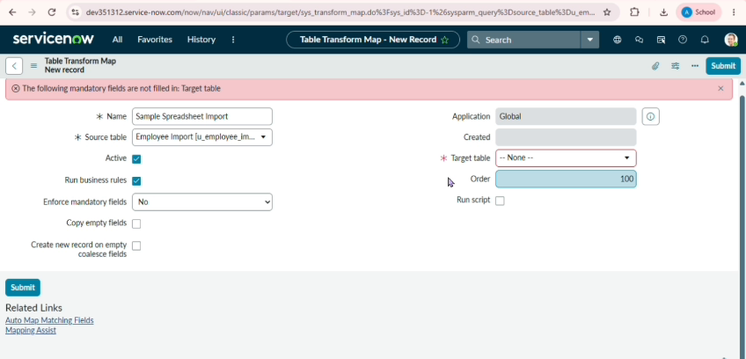
4 Field Mapping
The source fields were mapped with the corresponding fields in the target table so that the employee information could be transformed correctly.
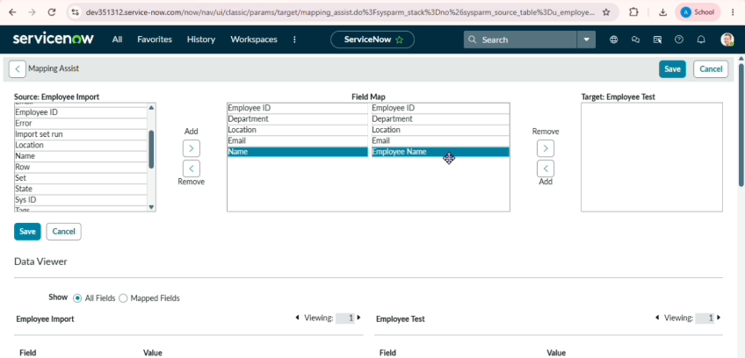
5 Final Output
The spreadsheet data was successfully transformed and imported into the target table. The imported employee records were verified in ServiceNow.
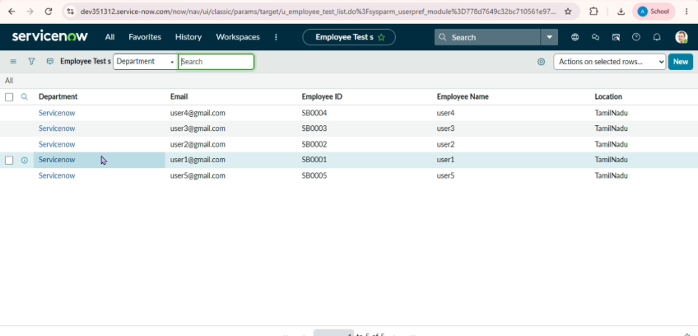
6 Report Creation
Reports were created from the imported employee table to display employee information in a clear and useful format.
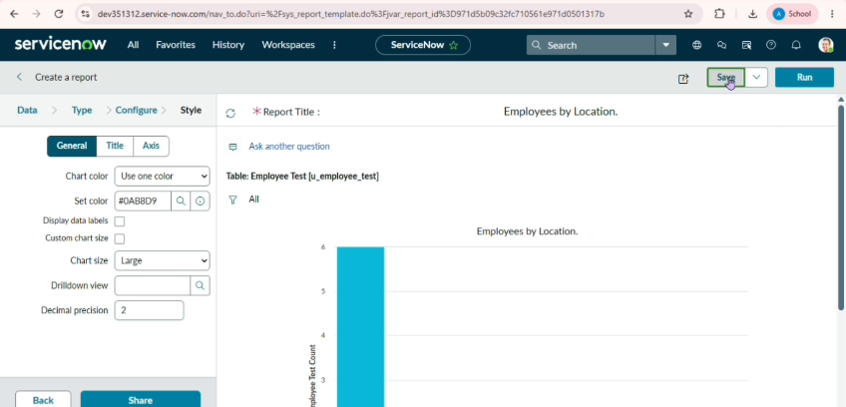
7 Dashboard Output
The reports were added to the Employee Analytics Dashboard to provide a visual summary of the employee data.
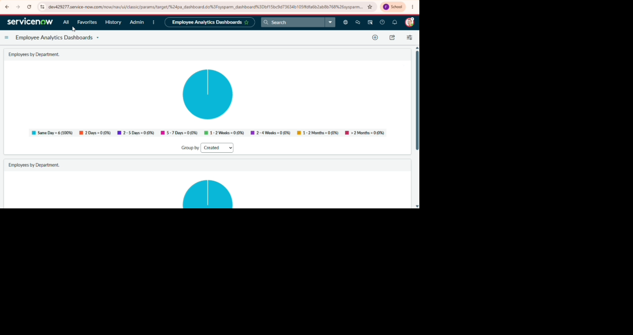

8. Prepare the Spreadsheet
The employee data was prepared in a spreadsheet with the required fields and records. The spreadsheet was used as the source for the ServiceNow data import process.
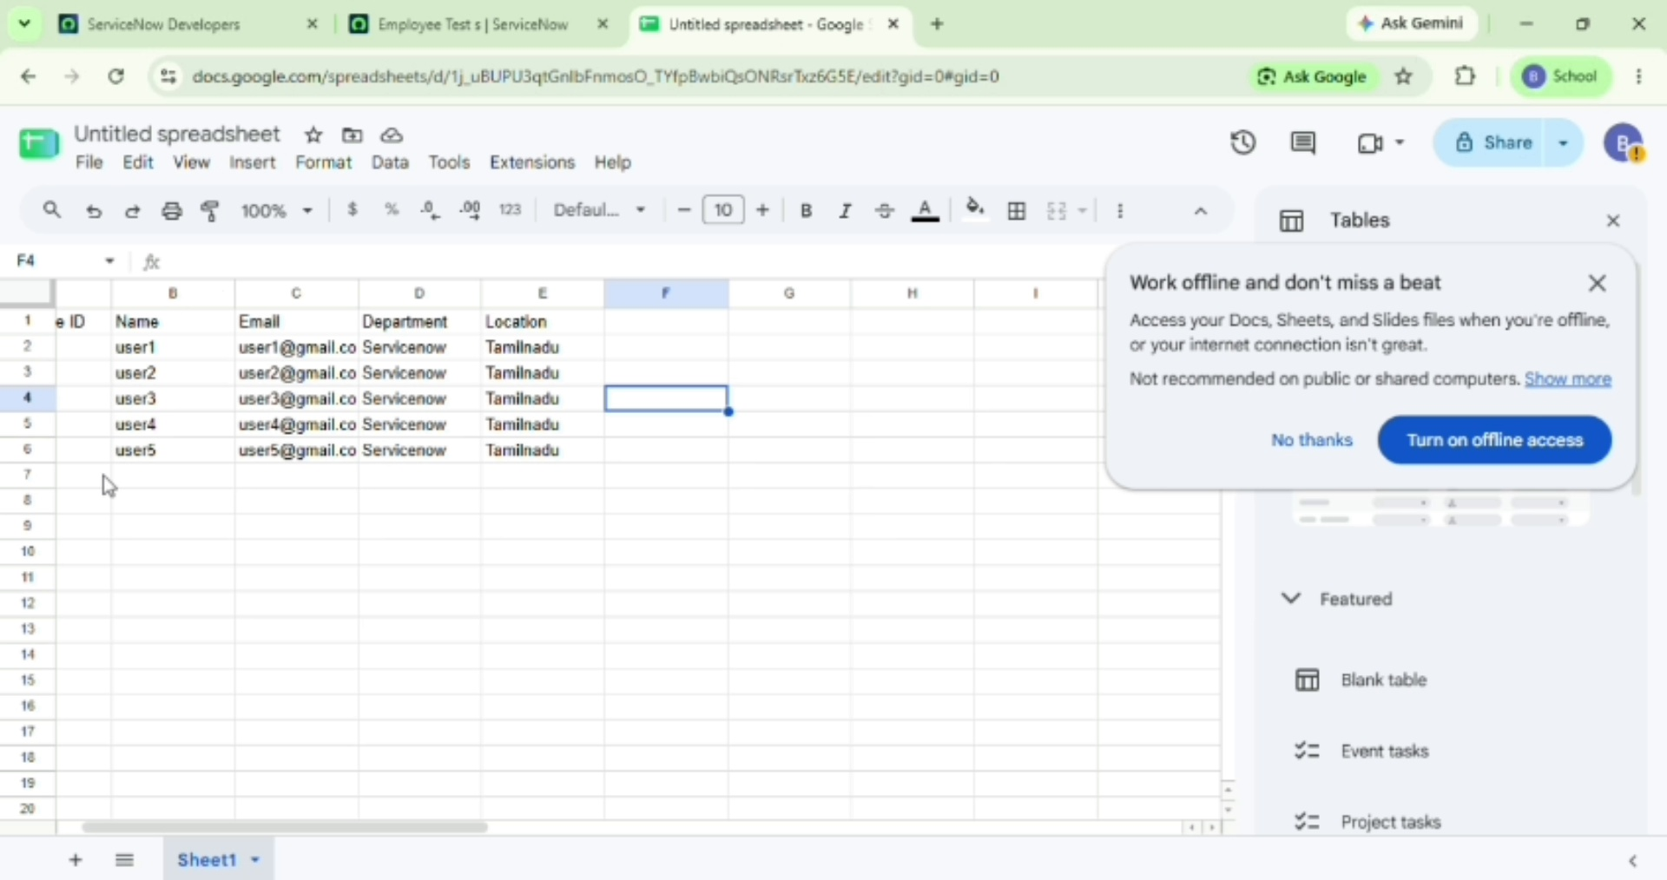
Screenshot – Prepare the Spreadsheet

9. Load the Spreadsheet into ServiceNow
The spreadsheet was uploaded into ServiceNow through the import process. ServiceNow created/used the import-set data as the source for the transformation.
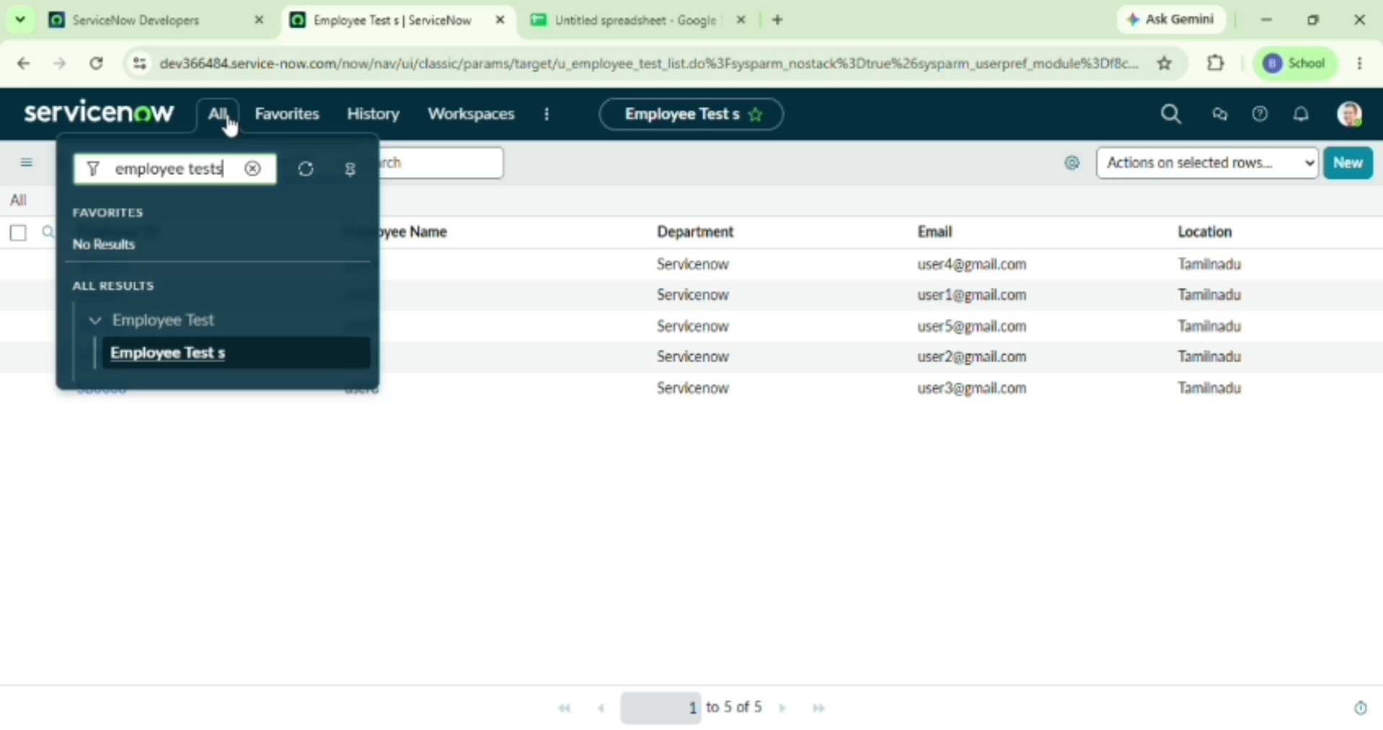
Screenshot – Load the Spreadsheet into ServiceNow

10. Configure the Transform Map
A Transform Map was configured to transfer data from the imported source table to the required target table. The source and target tables were selected for the transformation.
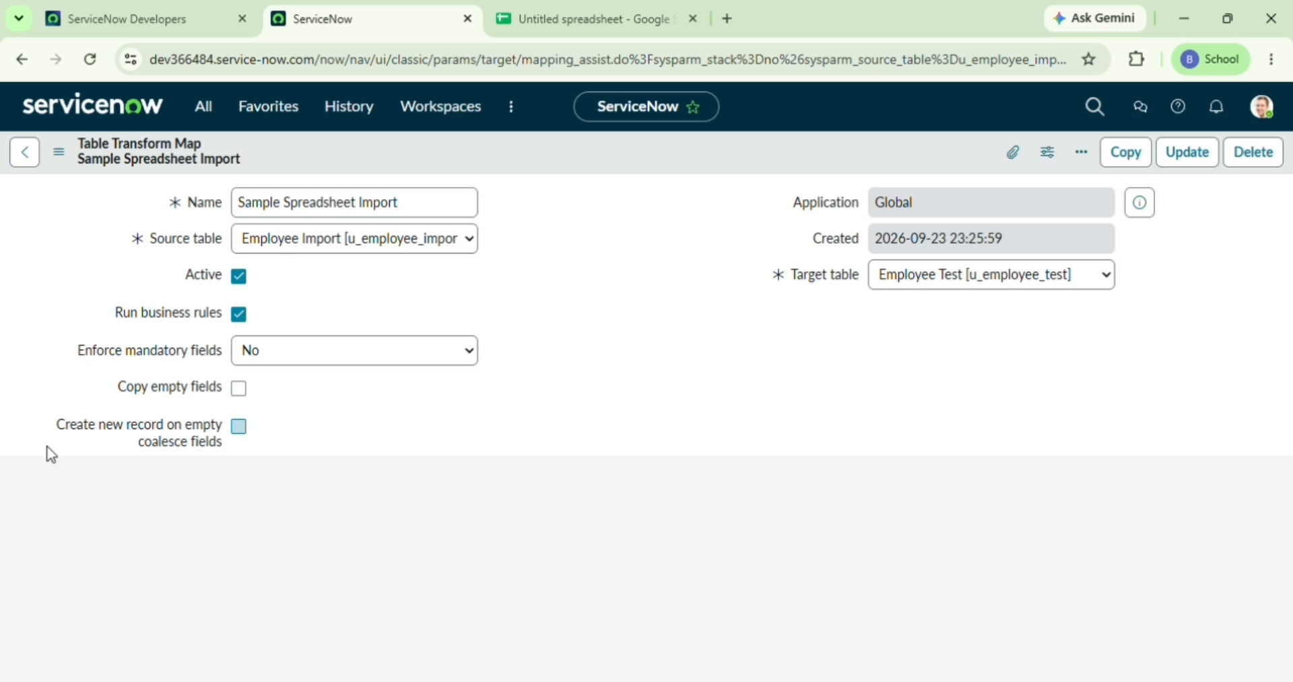
Screenshot – Configure the Transform Map

11. Map the Fields
The source fields from the imported spreadsheet were mapped to the corresponding fields in the target table. This ensured that each value was transferred to the correct field.
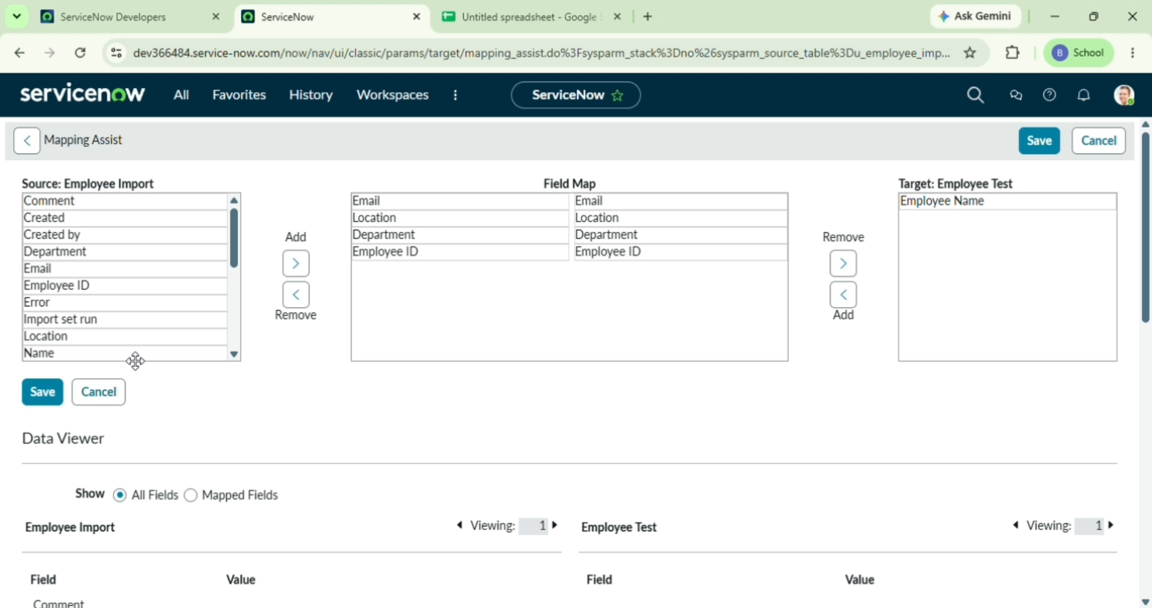
Screenshot – Map the Fields

12. Execute the Transformation
The Transform Map was run to transform the imported spreadsheet data and create/update records in the target table.
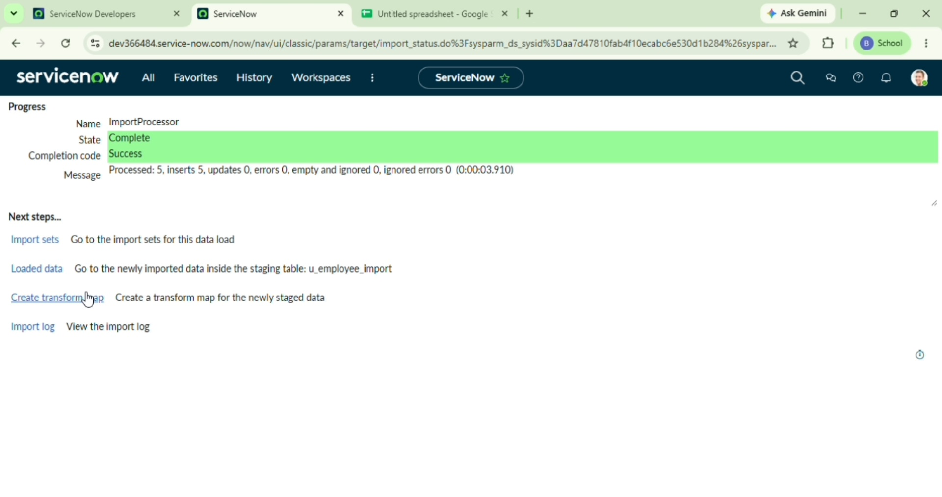
Screenshot – Execute the Transformation

13. Verify the Imported Records
The target records were checked after the transformation. The imported employee information was displayed in the target table, confirming that the data was transferred successfully.
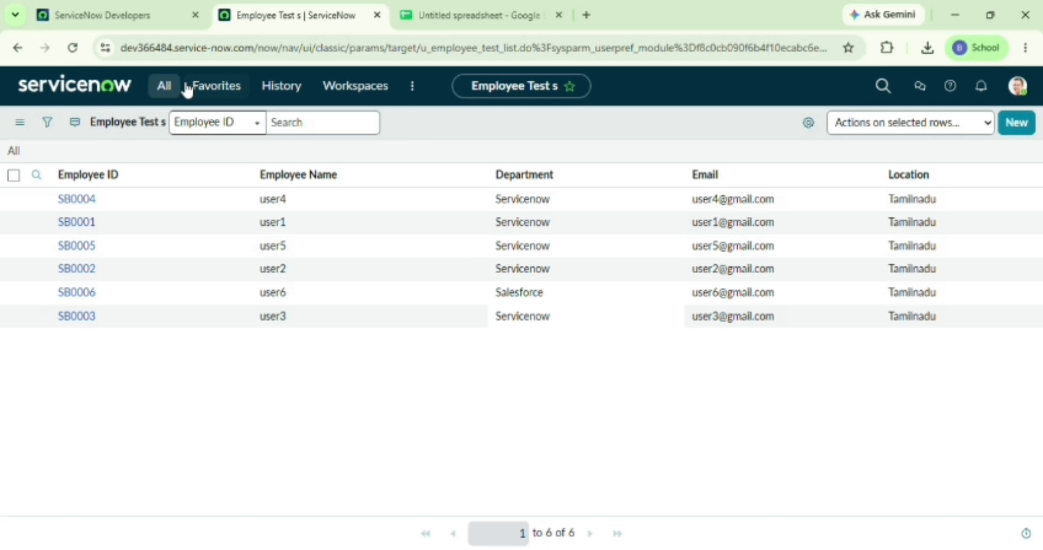
Screenshot – Verify the Imported Records

8. ADVANTAGES & DISADVANTAGES
8.1 Advantages
- Duplicate Prevention: Coalesce keys guarantee data integrity.
- Extensibility: JavaScript transform scripts enable complex custom logic.
- Auditability: Complete logging and rollback capabilities for every import run.
8.2 Disadvantages
- Large files ($>100\text{k}$ rows) require chunking or MID Server setups to prevent memory overhead.
- Uncleaned source files with complex custom encoding can cause unexpected staging errors.

9. CONCLUSION
The automated ServiceNow Import Set and Transform Map solution provides a reliable, secure, and highly efficient framework for enterprise data migration. By combining field mapping rules, Coalesce checks, and custom transform scripts, the system eliminates duplicate entries, automates data validation, and significantly reduces manual administration overhead.

